[no date, from Roma to Fenya]

Hello, wonderful Fenichka!

I can’t even remember the last time you wrote me a letter, for what reason I don’t know. Truth be told, I was supposed to write to you myself, but I kept waiting for Lyova’s situation to improve and then we would write one together, and so it’s gone until today. I hope that will all soon change for him, and then everything will go better. As it so happens, Fenya, the way that things have worked out for Lyova recently can happen to anyone here and at any time. And for that reason I can say that, in my opinion, in order to avoid misunderstandings and troubles and so on, a person, in order to think of a life of independence, should necessarily

[2]

have sufficient means, that is, arrange matters so as not to be answerable to any master and not to have to be at the factory where anything can happen at any time. And to make yourself independent, so as not to be obliged to others, is possible here. Only this takes a while, because, as in Russia, to do anything you need money. I, thank God, am in a pretty good situation for now. I earn from 12 to 15 dollars a week, but I’m still dependent on my boss. But for the moment I have a great job, but I hope that a year from now I will have arranged matters for myself. Then things will be clearer, though I’ll have to work more, but on the other hand for my own benefit. Next time I’ll write more. Sorry that this is so short. Be healthy.

Your friend Roma

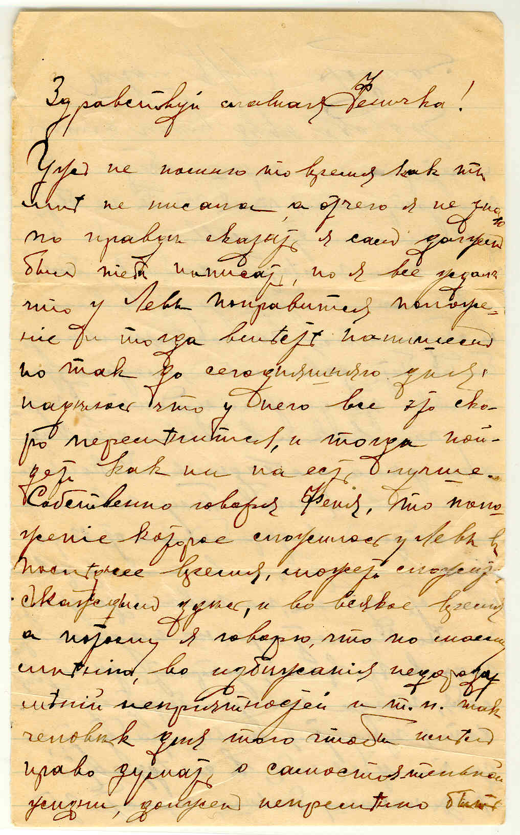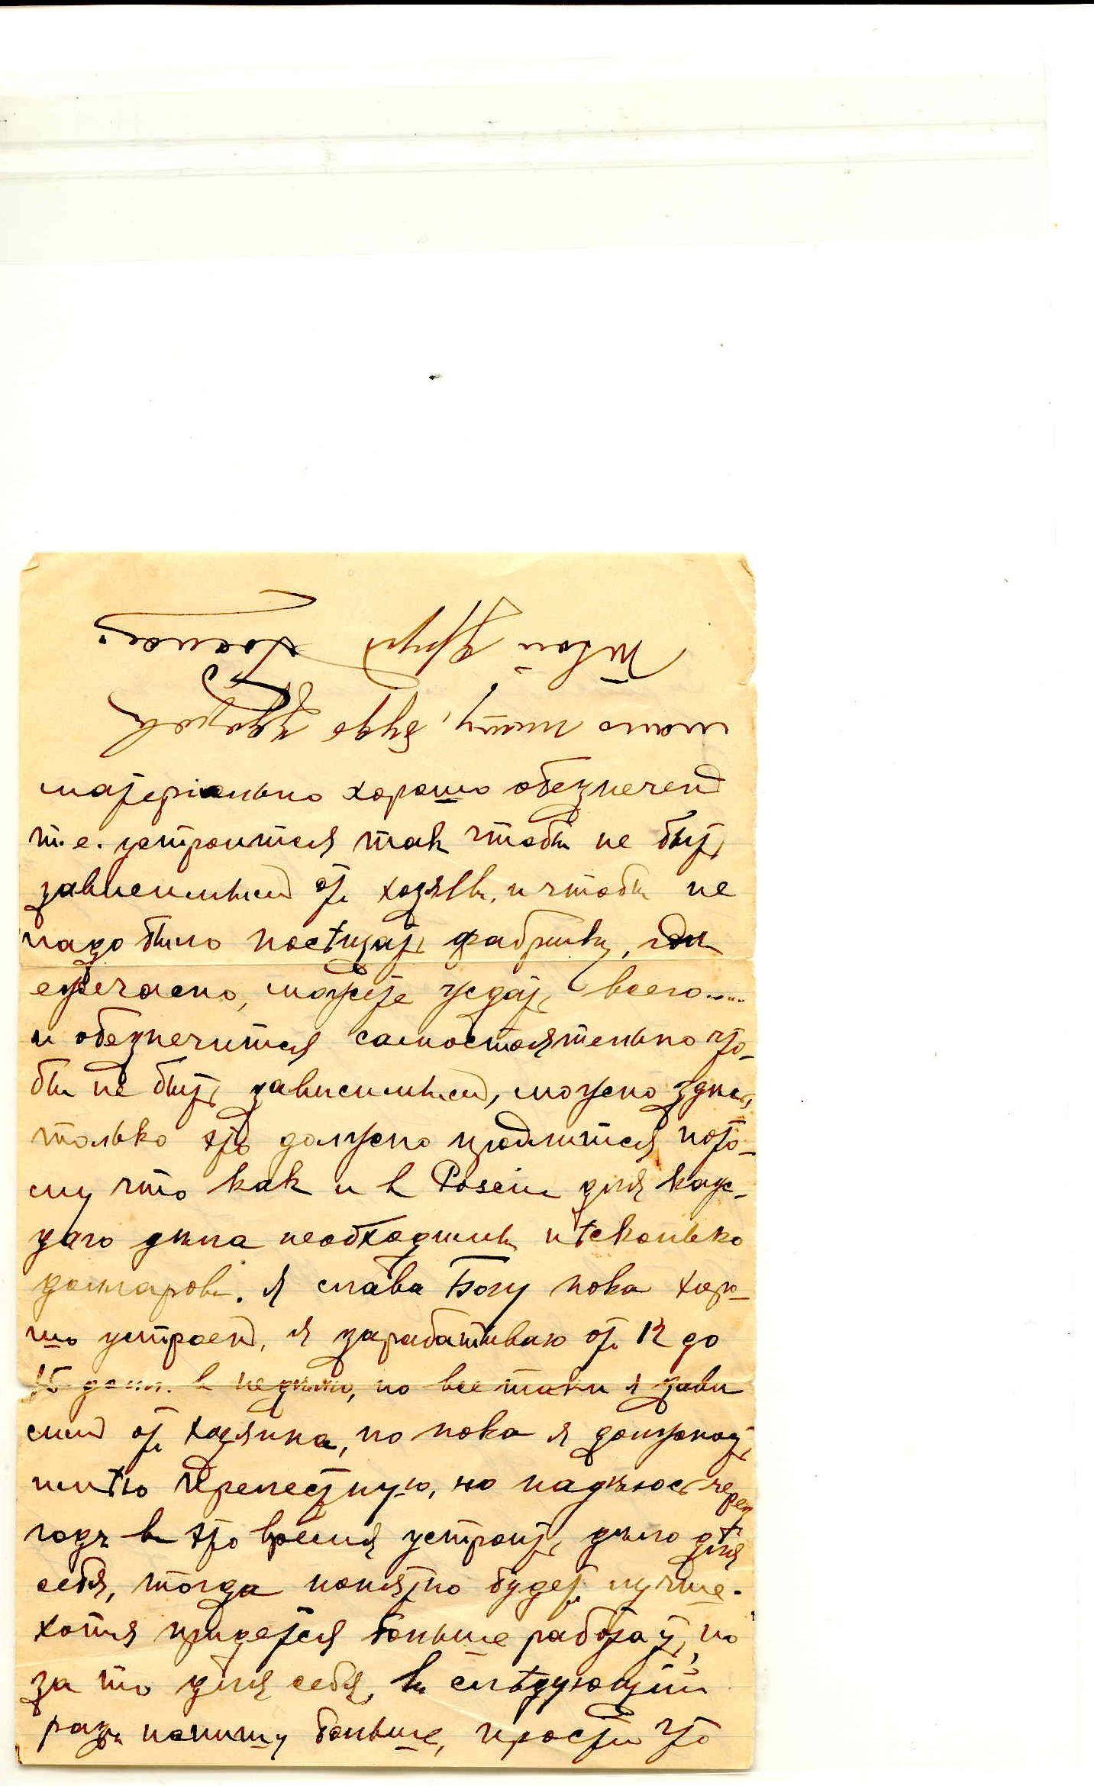
Signature is upside-down at the top of the page

