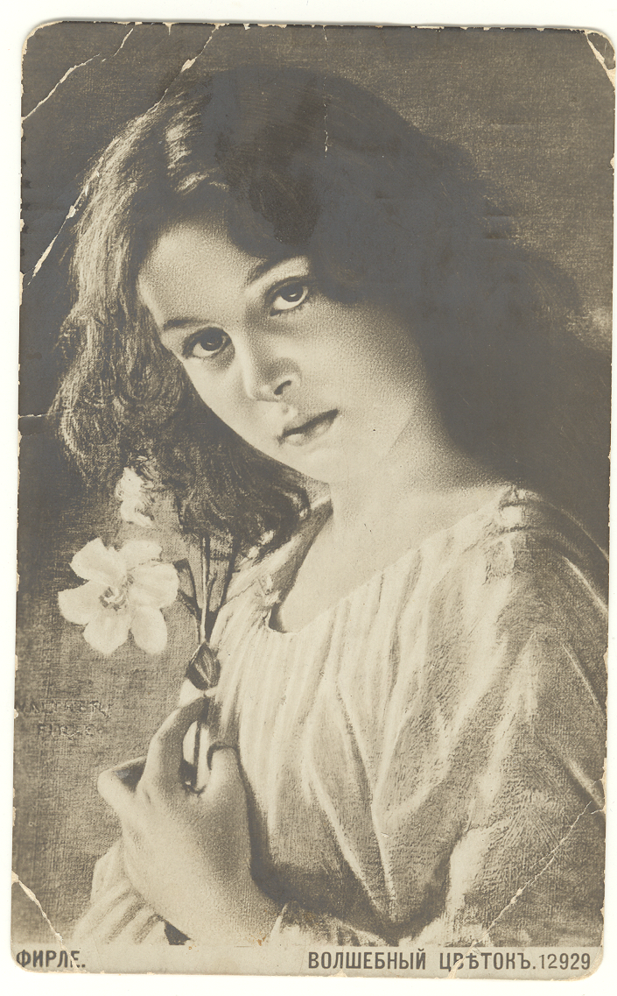

March 28, 1914 (?)

From sister Sophia (Sarah) for Fannie Ronen at the home of Passof, 64 E 102 St. in New York. (summary)

Feeling well. Letter from you yesterday; glad. Were waiting a long time for a letter. First Seder was today. Didn’t go to school today. Saturday they will be dismissed and given their grades. Best regards to Lova, best regards from the family.



